Views - Assignment 11

- Create a view that shows all of the customers who have the highest ratings.

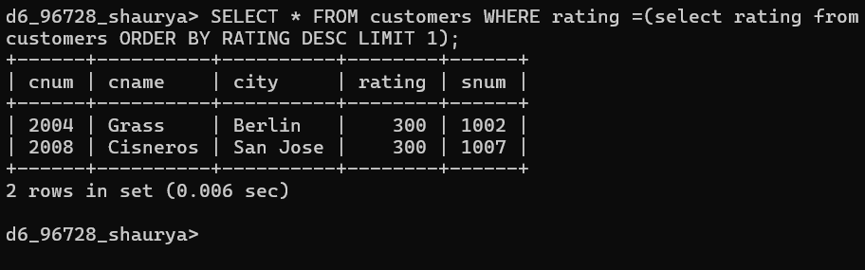

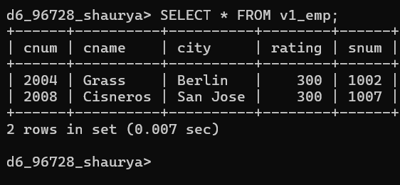

- Create a view that shows the number of salespeople in each city.
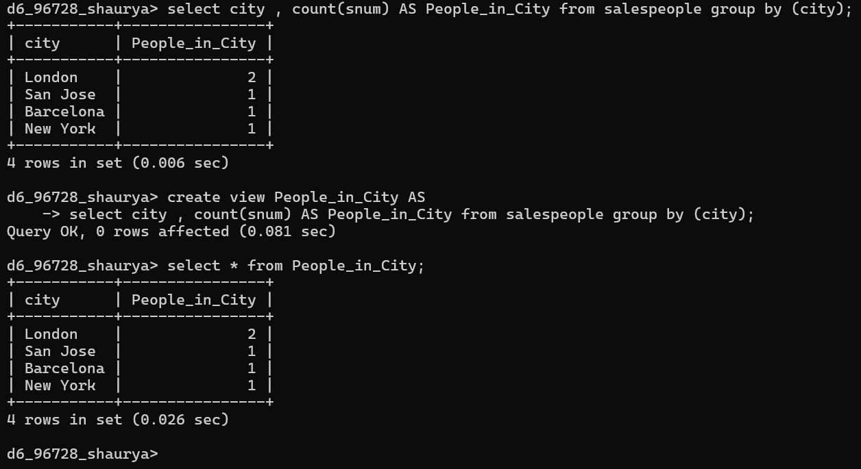

- Create a view that shows the average and total orders for each salesperson after his or her name. Assume all names are unique.

STEP 1 :
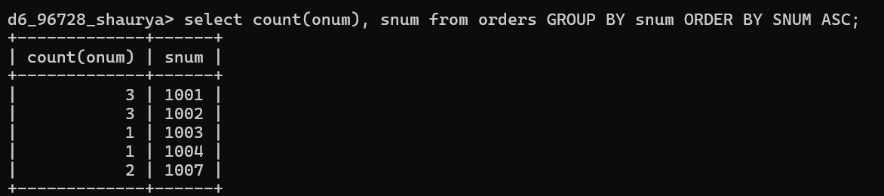

STEP 2 :
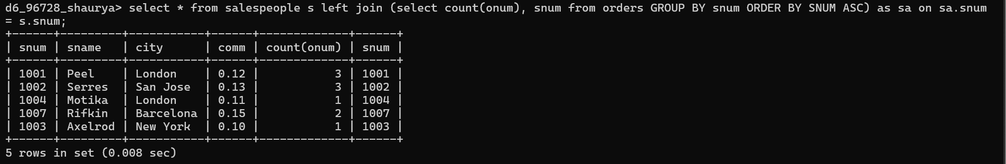

STEP 3:
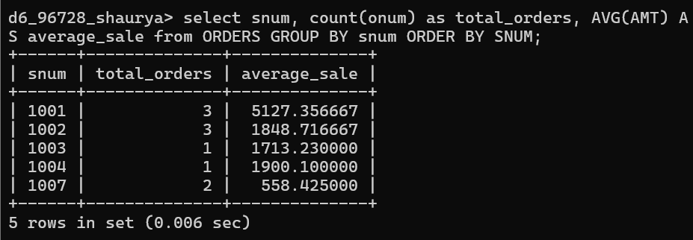

STEP 4:
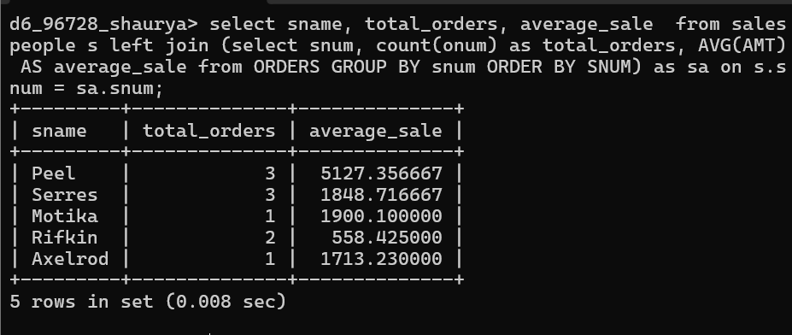

STEP 5:
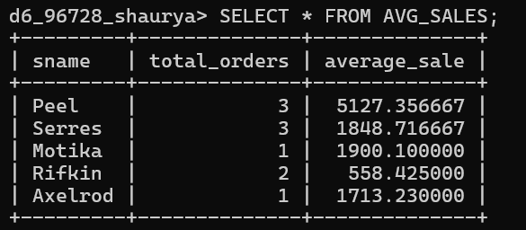

- Create a view that shows each salesperson with multiple customers.

STEP 1:

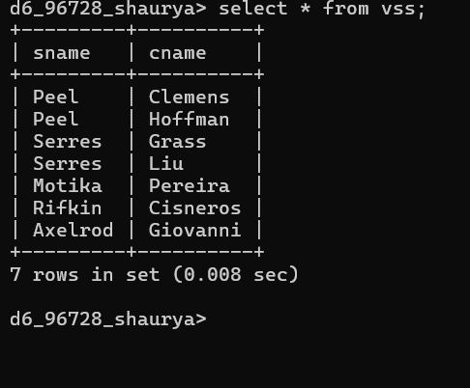

Changing Values through Views.

- Which of these views are updateable (will allow DML operations)?

#1 | Create View Dailyorders
as Select Distinct cnum, snum, onum, odate from Orders;
Not Updateable
Reason: Uses DISTINCT, Views with DISTINCT are not updateable

#2 | Create View Custotals
as Select cname, Sum (amt) Sum_Amt from Orders, Customers where Orders.cnum=Customers.cnum Group by cname;
Reasons: Uses SUM() aggregate, Uses GROUP BY, Uses join of two tables
Any of these alone already makes the view non-updateable.

#3 | Create view Thirdorders
as Select * from Dailyorders where odate=’1990-10-03’;
Not Updateable
Reason : Based on another non-updateable view (Dailyorders).

#4 | Create view Nullcities
as Select snum, sname, city from Salespeople where city is NULL
OR sname BETWEEN ‘A’ and ‘MZ’;
Updateable Reason:
Single table
No aggregate
No GROUP BY
No DISTINCT So DML operations allowed.

- Create a view of the Salespeople table called Commissions. This view will include only the snum and comm fields. Through this view, someone could enter or change commissions, but only to values between .10 and .20.
- 